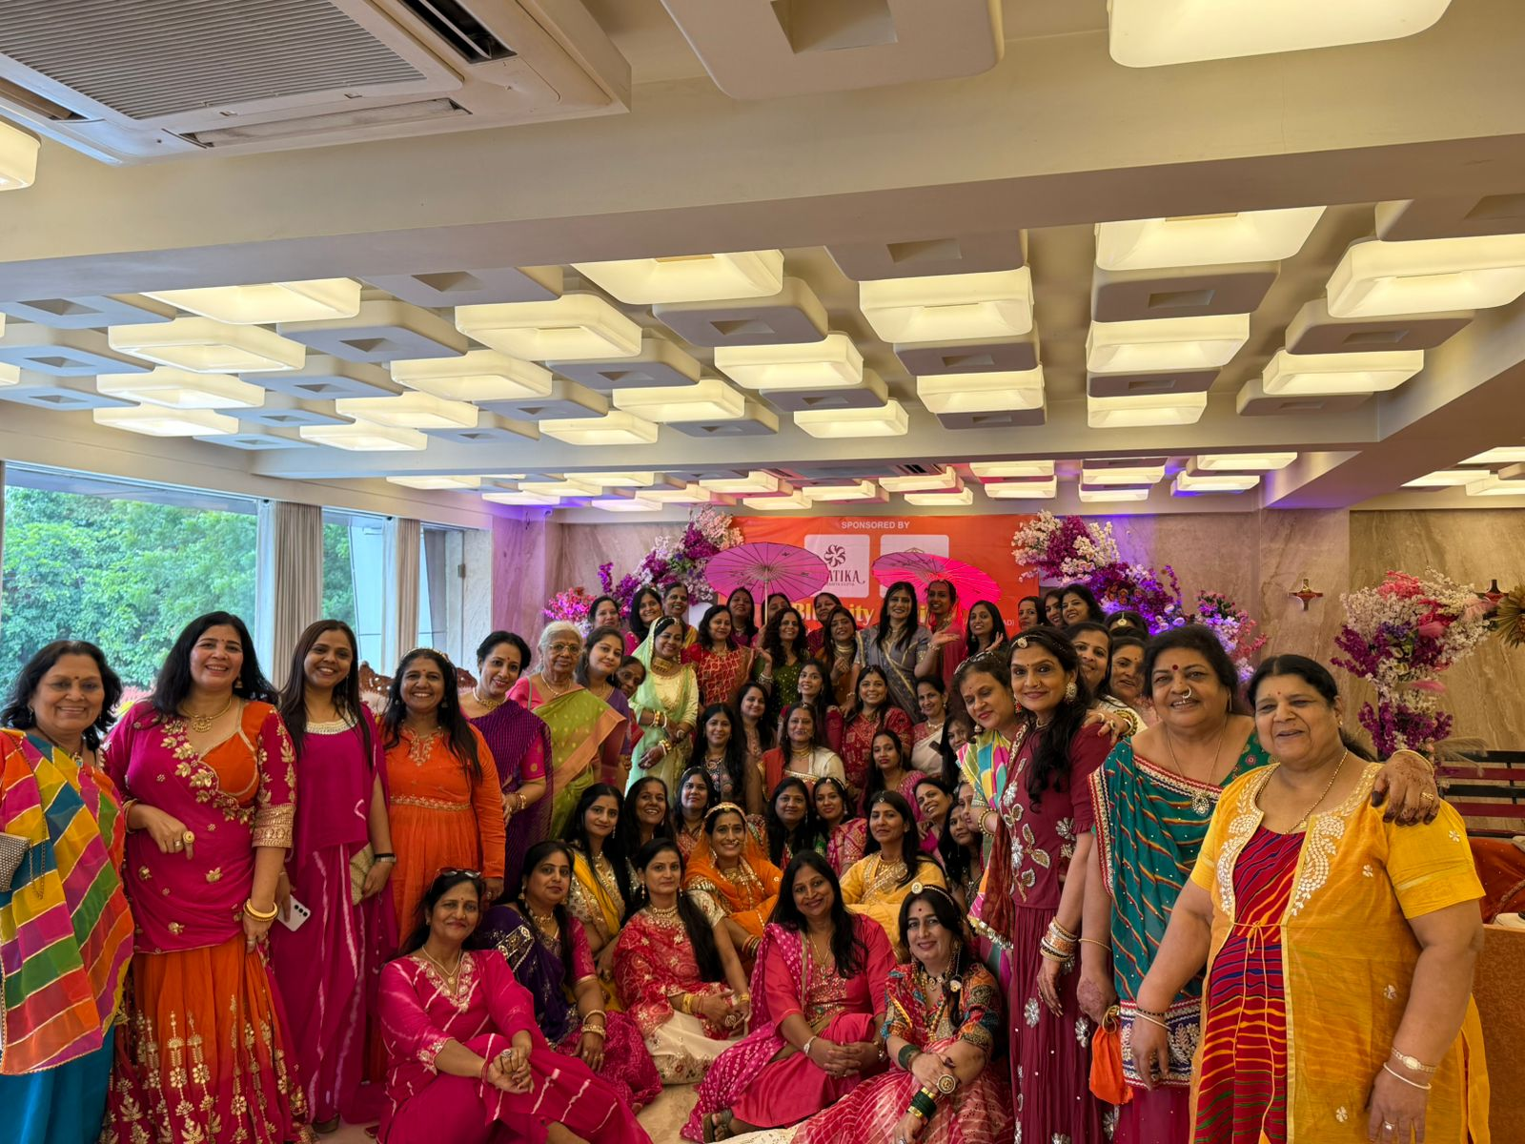
Celebration of Haryali Teej by Marwari Ladies at Ahmedabad
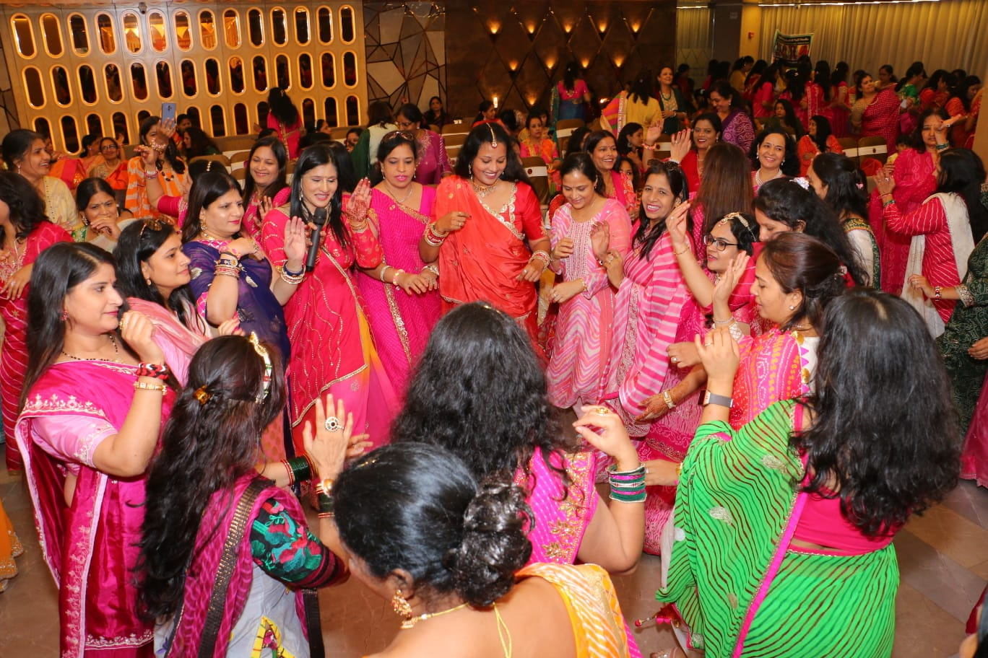
Celebration of Gangaur
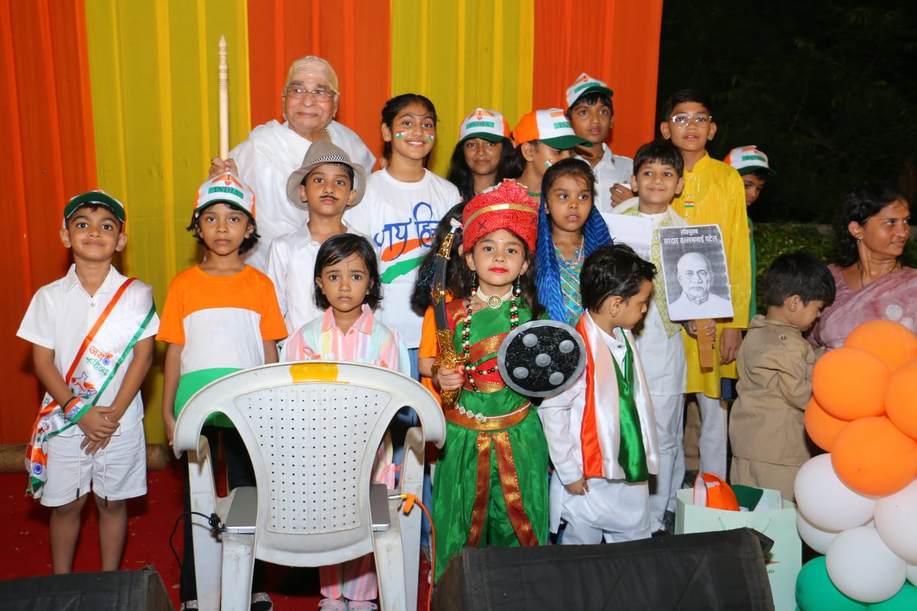
Fancy Dress Competition for Kids On Eve of Independence Day Celebration

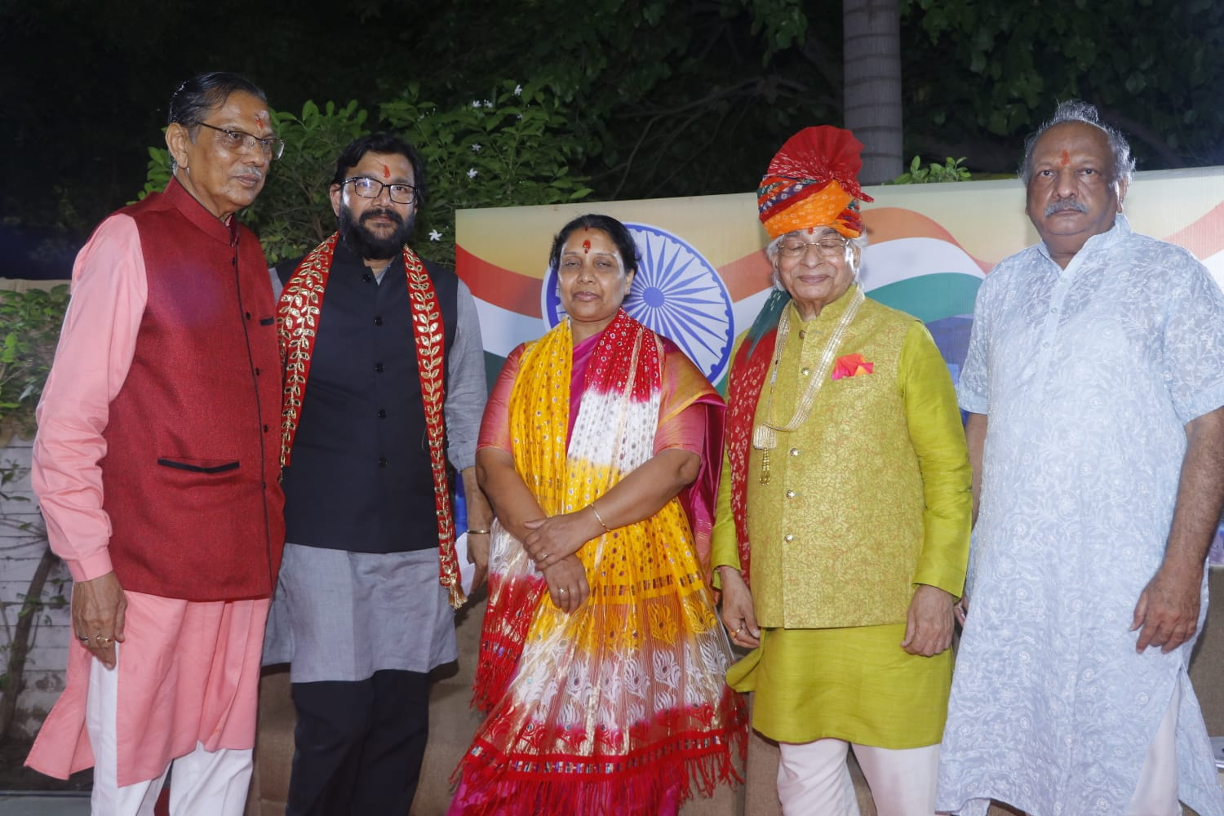
Mayor Smt Pratibha Jain with Shri Zabbarmal Sa Sankhlecha, Shri Deepak Jain, Shri Dr. M M Singhi and Shri CA Rajendra Agarwal In celebration at Bluecity Positive Forum
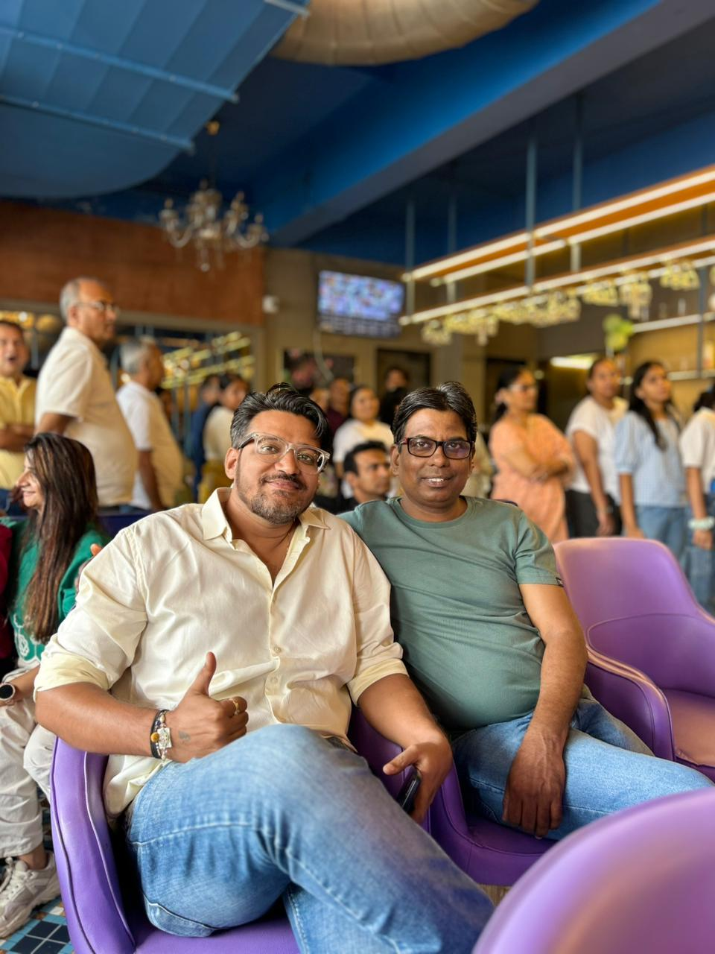
Pre-Deepawali Celebration Get together

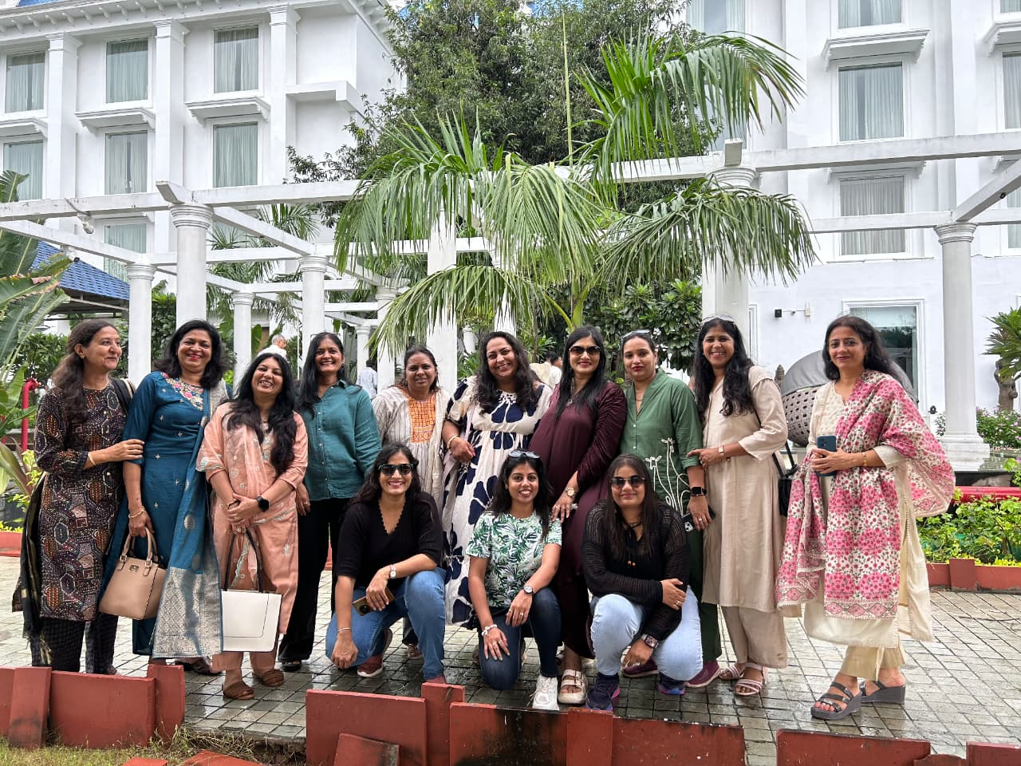
Monsoon Picnic

